October 19th 2022 General PTO Meeting

Attendance
Tammie Guyer
Amy McClean
Kathleen Mason
Lisa Molina
Carrie Kressman
Jessica Roberts
Yasmin Morton
Ashley Moser
Josh Corbat
Ethan Burton
Astra Ball
Brittany Reuter
Christina Hutchinson
Deborah Brown
Meredith Sewell
Hafsa F
Bridgid Hines
Erinn Ferry Jones
Allie Lindahl
Natalie Oren
Martha Fisk
Layvette Evans
Emily McIntyre
Shanna Darwish
Sonja McKay
Tiki Wrighton

Budget Approved:
- Ashley Moser motioned for approval and Carrie Kressman 2nd - Budget approved by all
- Jessica wants to be able to point out where the money that we are raising is going. We can’t specifically say, but we can say that due to the funds raised, we are able to provide a food pantry and purchase vacuums and tools.

Fall Festival:
- Grade level will have booths that will need to be monitored throughout the night.
- General PTO sign up for other things like firepit, dance floor, slide, etc. Look for those signups.
- 3 Food trucks with great options. Giant slide, but no bouncy house this year.
- Pumpkin carving, come with pumpkin carved and electronic light in pumpkin (leadership team will be judging)
- Raffle ticket to possible win bigger prizes
- Drama club will do a performance (they will have a booth)
- Face painting (middle school elective) - Paradise leading this
- Food Drive in lieu of charging admission (this will go to our food pantry)

Food Pantry
- Possible setup square link for donating $ to the food pantry

Director Updates
- Portfolio coming up next week
- Bullying prevention week/Spirit week coming up next week
- Field experiences kicking into gear
  - 7th grade going to State fair to look at the Physics of the rides
  - DC Trip plans for 7th grade
  - Charlotte Trip just completed before Fall Break for 7th grade
  - Outward bound plans for 8th grade
- Leadership structure
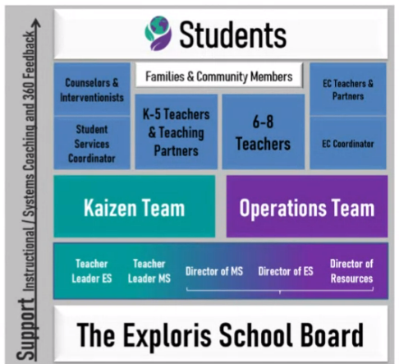
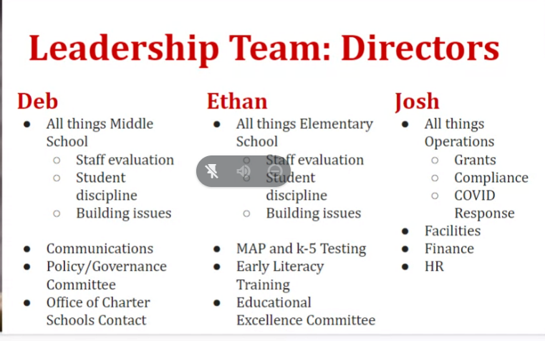
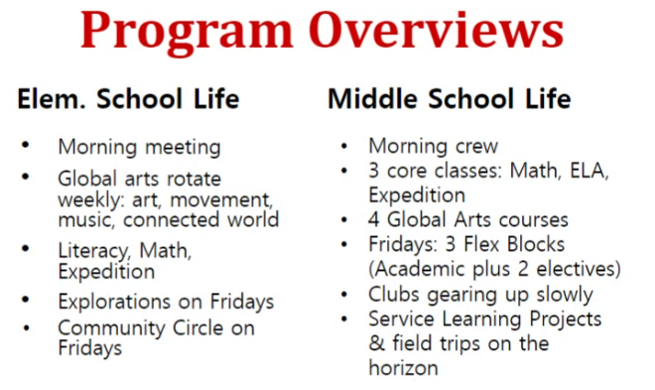
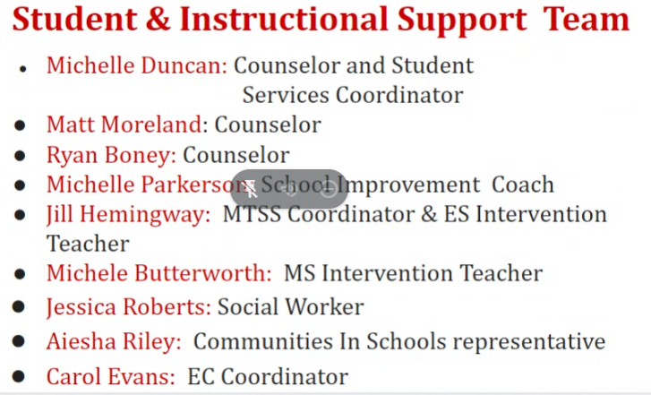
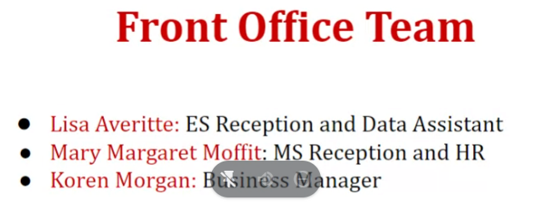
- Key Issues and Initiatives
  - Facilities
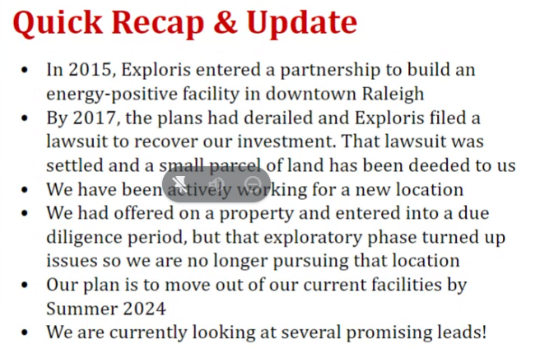
  - Responsive Classrooms
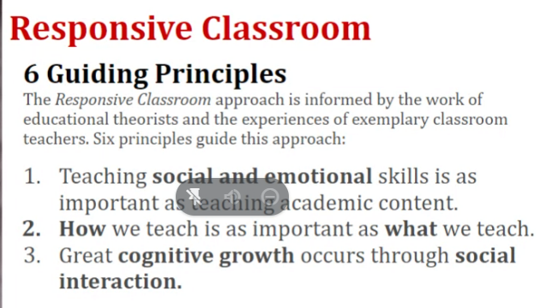
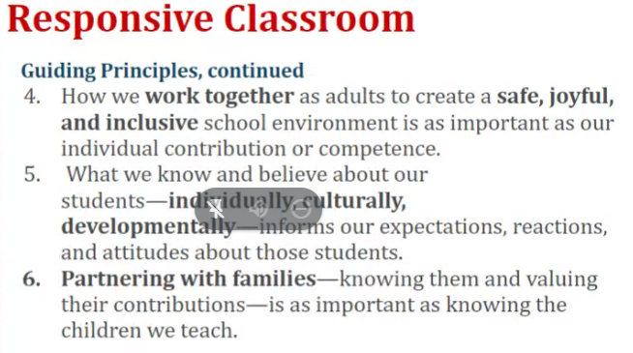
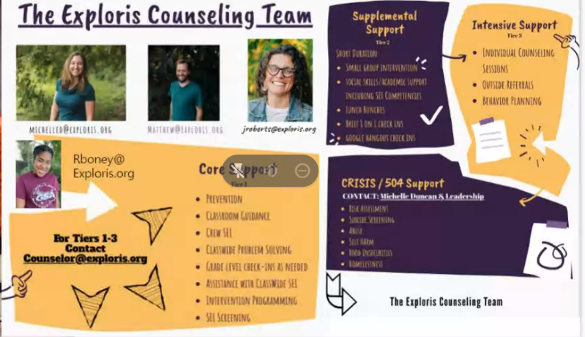
  - Covid Response
    - Low rate of cases

